### 1.2.2 Biophilic Design Integration.

The natural elements of Okun-Agaja provide an ideal backdrop for incorporating biophilic design elements, which are crucial for enhancing guest well-being. Key aspects include:

**Natural Light and Ventilation:** The site's elevation and orientation can be leveraged to maximize natural light and cross-ventilation, reducing the need for artificial lighting and mechanical cooling, thereby promoting sustainability.

**Outdoor Spaces:** The diverse landscape offers numerous opportunities to create outdoor spaces that encourage interaction with nature. These spaces can include walking trails, viewing platforms, and outdoor relaxation areas that blend seamlessly with the natural environment.

**Aesthetic and Immersive Experiences**: The lush vegetation and rolling hills provide an aesthetically pleasing environment that enhances the sense of tranquillity and relaxation. This natural beauty, combined with thoughtful design, can create immersive experiences that promote a deeper connection with nature and foster mental and physical well-being.

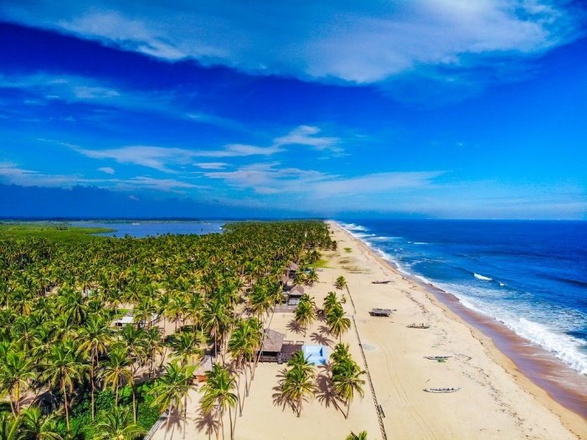

Figure 9: View of Okun Agaja, around the subject site (source: Uba, n.d.)[1]

### 1.2.3 Strategic Advantages of Okun-Agaja

Serenity and Accessibility: Okun-Agaja offers a serene location away from the hustle and bustle of urban life, providing a perfect retreat for tourists seeking relaxation and rejuvenation. Despite its tranquil setting, the site remains accessible to urban amenities, ensuring visitors can enjoy modern conveniences while disconnecting from city stressors.

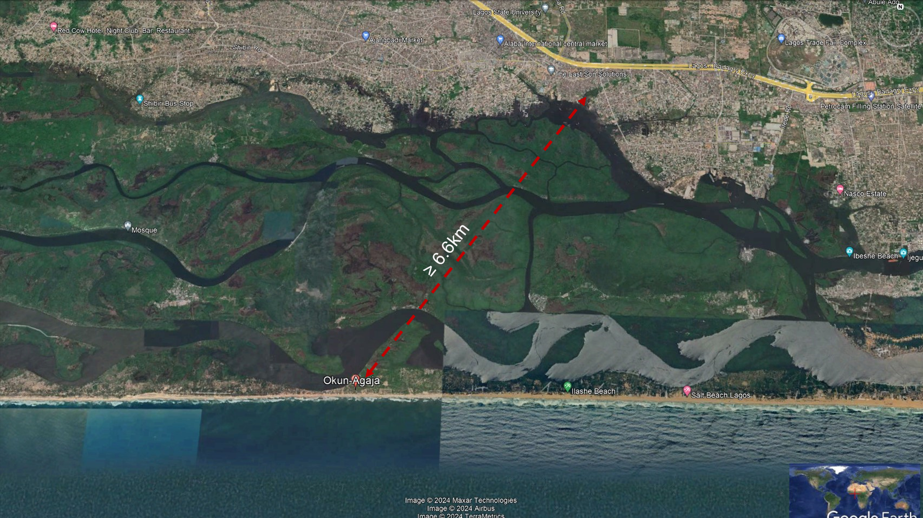

Figure 10: Google Earth aerial view showing the approximate distance of the site to the Lagos urban area. (Source: Google Earth).

Lagos State boasts an extensive and efficient transportation network, crucial for facilitating seamless movement for both residents and tourists. The image below highlights the routing from the Lagos Central Bus terminal to Okun-Agaja, as well as the terminal’s proximity to the Murtala Muhammed International Airport.

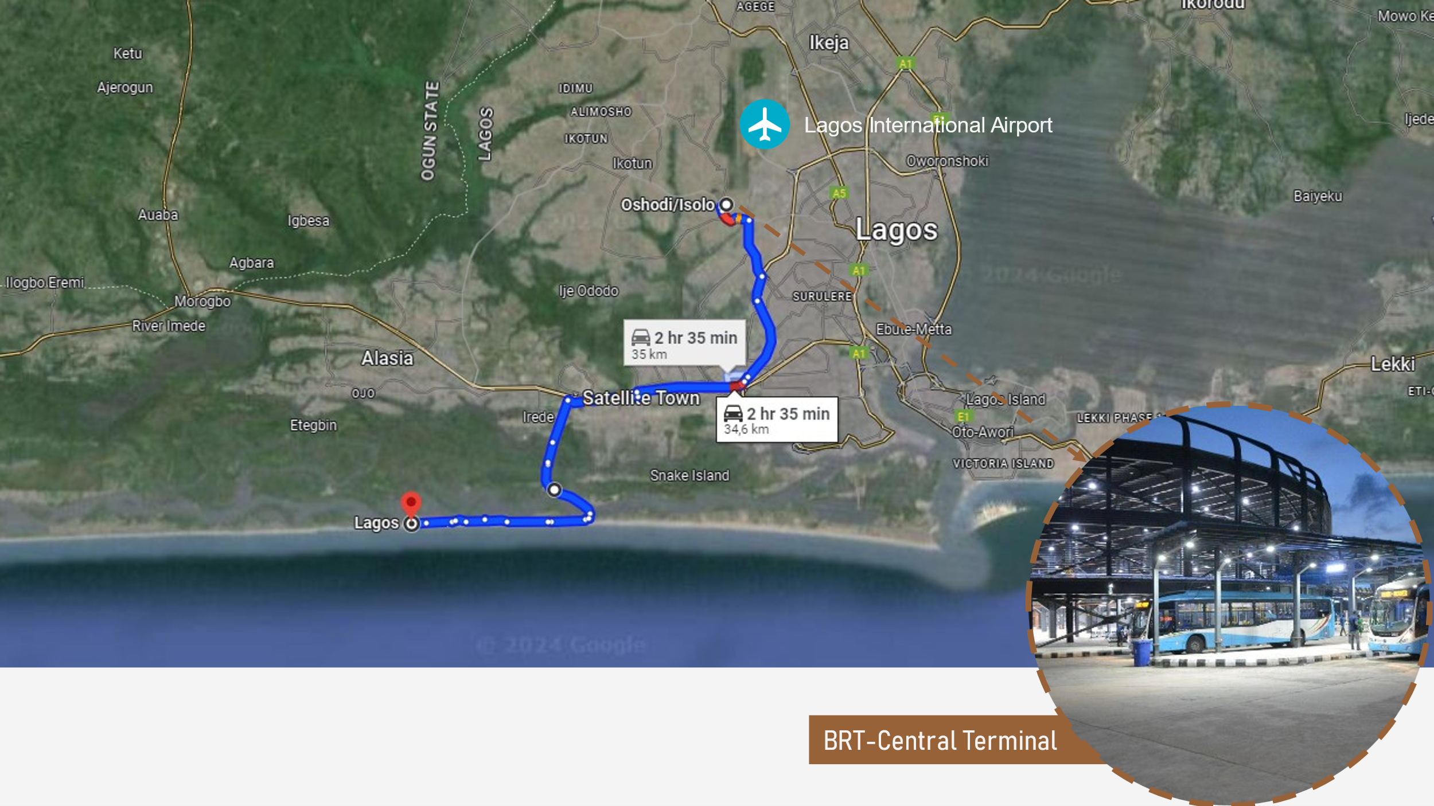

Figure 11: Google Earth aerial view showing connecting routes to the subject site (Source: Google Earth).

**Ecotourism Potential:** The area's natural beauty and ecological significance make it an excellent location for ecotourism. Initiatives can include eco-friendly accommodations, conservation programs, and educational tours that highlight the region’s biodiversity and cultural heritage.

## 1.3 Subject Site

The subject site is shown in the figure below.

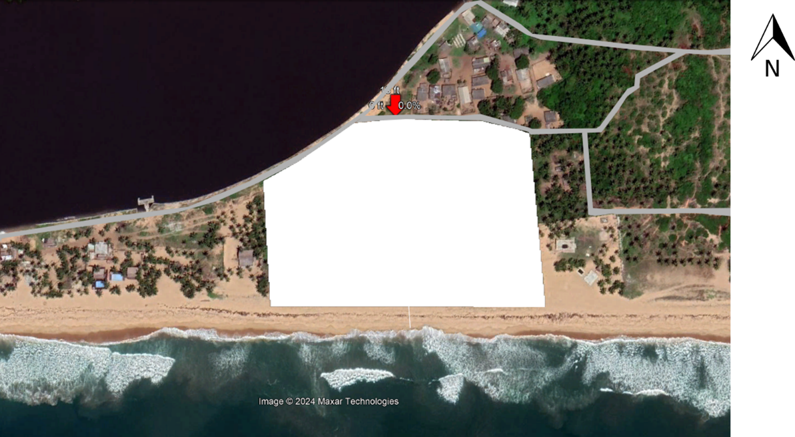

Figure 12: Map showing the subject Site. (Source: Google Earth).

The site has a perimeter of 462 meters and an area measuring 54,000 Sqm, it also has a relatively flat topography and is approximately 4.2 kilometers away from the coastal line. It also enjoys an excellent road network which provides adequate accessibility options. There is also the availability of public transportation and pedestrian sidewalks. Safety and security concerns were also taken into consideration in the siting of the school, the community enjoys adequate security, very low crime rates, and traffic safety. Roads leading to the site have low vehicular activities and have strict traffic rules that keep vehicular speeds at low levels. Due to the low vehicular activity noise pollution from vehicular traffic is minimal. Furthermore, it is not near any industrial establishment.

Table 1: Table showing criteria used in selecting the subject site. (Source: author).

|  |  |
| --- | --- |
| **Criteria** | **Subject Site** |
| **Proximity to Nature** | Adjacent to natural water bodies, The site has the Atlantic Ocean on its south border and the lagoon on its North-west borders |
| **Biodiversity** | High biodiversity, abundant flora and fauna |
| **Tranquility and Serenity** | Secluded location (away from urban activity) with minimal noise pollution |
| **Natural Healing Elements** | mineral-rich water sources (Seawater), Salt air, Beach Sand, Natural Sounds and coastal Plants |
| **Access to Outdoor Activities** | outdoor yoga areas (Beach Yoga), Beach walking, birdwatching spots, Surfing |
| **Sustainable Design** | Green building certification, renewable energy usage, Passive Building Strategies |
| **Biophilic Design Integration** | Incorporation of natural materials, indoor gardens, and water features |
| **Accessibility** | Close proximity to airports and major highways |
| **Community Engagement Opportunities** | Partnerships with local communities, cultural exchanges what |

Table 2: Site Selection using LEED V4.1 as a guide (Source: LEED v4.1)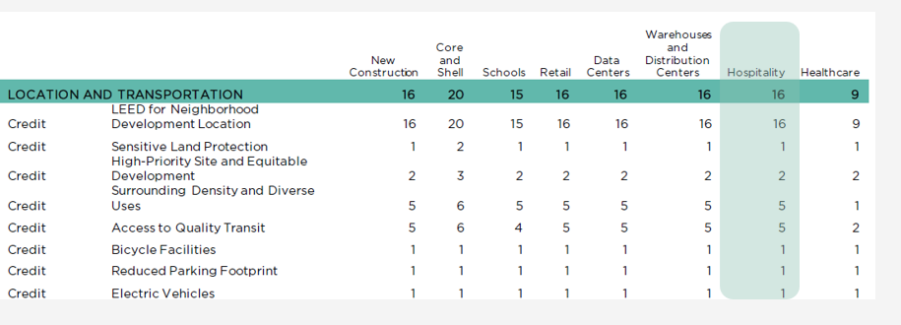

Tourism Infrastructure Site Selection Criteria Retrieved from LEED v4.1 LT Criteria (By the author).

|  |  |  |  |  |  |
| --- | --- | --- | --- | --- | --- |
| Credit/Prerequisite | Intent | Requirements | Points | SCORE | Notes |
| Lt Credit: Sensitive Land Protection | Avoid the development of environmentally sensitive lands. | Option 1: Locate the development on previously developed land.  Option 2: Locate the project on land that does not meet specific criteria regarding prime farmland, floodplains, habitats, water bodies, and wetlands. | 1 | 0 |  |
| Lt Credit: High-Priority Site And Equitable Development | Encourage investment in high-priority sites. | Option 1: Locate the project on an infill location in a historic district where household income is ≤  80% AMI, OR 20% of population is ≤ the poverty rate in state, provincial, or other regional jurisdiction, OR unemployment is at least 150%  of the state, provincial, or other regional jurisdiction.  Option 2: Locate the project on a site listed by the EPA as a National Priorities List or equivalent.  Option 3: Locate the project on a brownfield site and perform remediation. | 2 | 2 |  |
| Lt Credit: Surrounding Density And Diverse Uses | Conserve land and protect farmland and wildlife habitat by encouraging development in areas with existing infrastructure. | Option 1: Locate the project in or near high-density areas with specified minimum densities. Option 2: Locate the project within 1/2-mile walking distance of diverse uses. | 5 | 0 |  |
| Lt Credit: Access To Quality Transit | Encourage development in locations with multimodal transportation options. | Locate the project within 1/4-mile walking distance of bus, streetcar, or rideshare stops, or within 1/2-mile walking distance of bus rapid transit stops, light or heavy rail stations, or ferry terminals. | 5 | 0 |  |
| Lt Credit: Bicycle Facilities | Promote biking and transportation efficiency. | Provide short-term bicycle storage for at least 2.5% of peak visitors and long-term storage for at least 5% of regular building occupants. Provide showers for at least 0.5% of full-time equivalent occupants. Ensure connection to a bicycle network. | 1 | 1 |  |
| Lt Credit: Reduced Parking Footprint | Minimize environmental harm from parking facilities. | Do not exceed the minimum local code requirements for parking capacity. Provide parking for carpooling and ride-sharing vehicles. Implement strategies to reduce parking demand, such as discounted parking for low-emitting and fuel-efficient vehicles. | 1 | 1 |  |
| Lt Credit: Electric Vehicles | Reduce pollution from automobile use. | Provide electric vehicle supply equipment (EVSE) in 2% of all parking spaces used by the project. Additionally, provide designated parking spaces for low-emitting and fuel-efficient vehicles for 5% of the total parking spaces used by the project. | 1 | 1 |  |
| Total |  |  | 16 | 5 |  |

# 2.0 Climate Analysis.

The proper analysis of the climatic conditions of Okun-Agaja, Lagos State, Nigeria, is a vital step in designing sustainable tourism infrastructure that leverages passive building strategies. Through a thorough analysis of the local climate, the design can be refined to better respond effectively to environmental conditions, ensuring a more comfortable and enjoyable experience for visitors. Insights gotten from the climate analysis will inform the integration of passive design strategies, thereby enhancing the sustainability and operational efficiency of the tourism infrastructure.

Lagos State which is in the southwest region of Nigeria has a tropical savanna climate (Köppen classification Aw). It has two distinct seasons: the wet season and the dry season. These climatic variations significantly impact the design considerations for tourism infrastructure, necessitating a responsive and adaptive approach.

Nigeria possesses 55 weather stations of which 3 are in Lagos state Nigeria, these are situated in Ikeja, Lagos Marine and Lagos Island. (Eludoyin et al., 2013)[2].

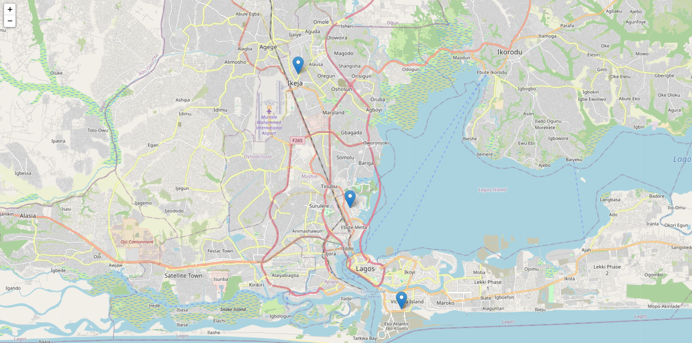

Figure 13: map showing the locations of the weather stations in Lagos Nigeria. (Source: Author)

## 2.1 Analysis

### 2.1.1 Temperature.

The temperatures experienced within the region are typically high throughout the year, with average highs ranging between 28 and 33 degrees Celsius and average lows typically ranging from 24 to 26 degrees Celsius. The hottest months span between December and April with average highs reaching 32°C and higher. March is the hottest month with average high temperatures at 33°C and average low temperatures at 26°C.

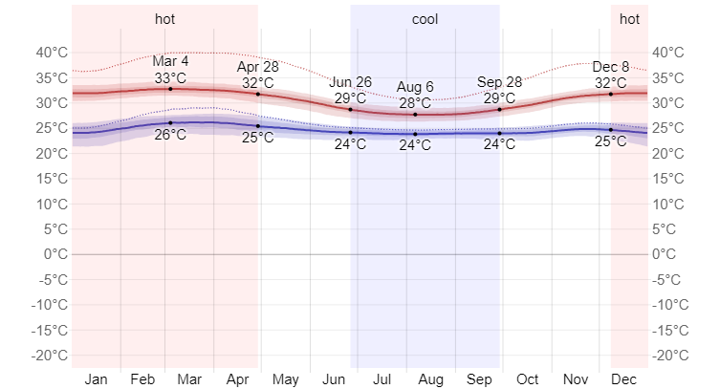

Figure 14:Monthly High and Low temperature distribution (Source: *Lagos Climate, Weather by Month, Average Temperature (Nigeria) - Weather Spark*, n.d.)[3]

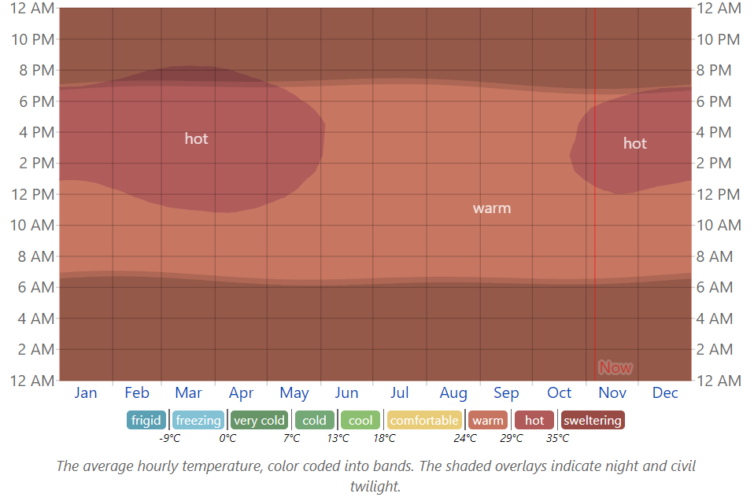

Figure 15: Average Hourly Temperature (Source: *Lagos Climate, Weather by Month, Average Temperature (Nigeria) - Weather Spark*, n.d.)

The chart above shows the average hourly temperature in Lagos state, and this shows that the weather is typically warm throughout the year. however, from November until May, temperatures between 29 and 36 degrees Celsius (hot) are recorded between 12 noon and 20:00.

### 2.1.2 Cloud Cover.

This varies across the seasons in a year. From the early days of November until the mid-point of February. It has been observed to be clearer with December being the clearest. The remaining parts of the year are observed to be cloudier lasting from mid-February until the 6th of November (8.8 months) with May being the cloudiest.

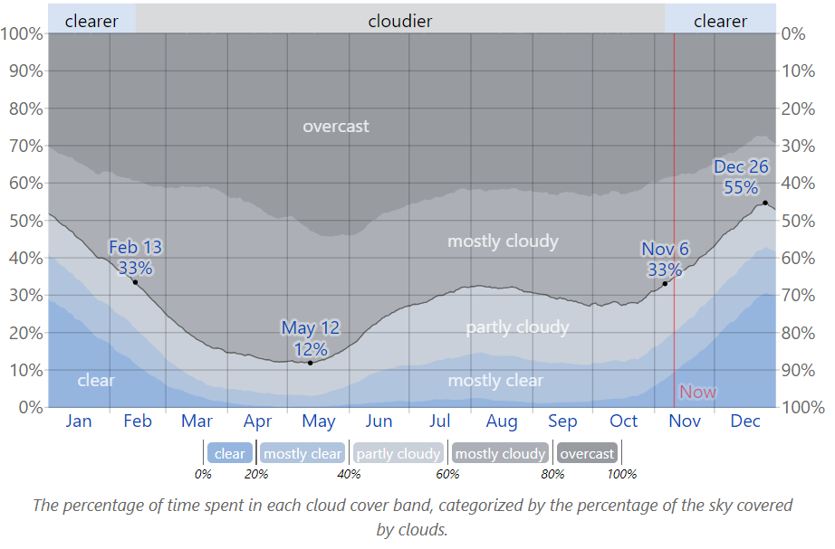

Figure 16: Cloud Cover Categories in Lagos State, Nigeria (Source: Lagos Climate, Weather by Month, Average Temperature (Nigeria) - Weather Spark, n.d.)[4].

### 2.1.3 Precipitation.

The wet season in Lagos Nigeria, last for approximately 6.7 months between April 8 and October 31, within the above-mentioned period the chance of a wet day ( day with liquid or liquid-equivalent precipitation ≥ 1) is above 36%.

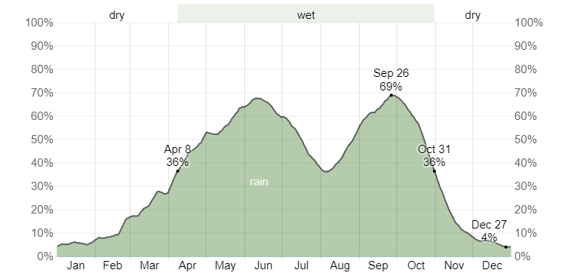

Figure 17:Daily Chance of Precipitation in Lagos State Nigeria (Source: Lagos Climate, Weather by Month, Average Temperature (Nigeria) - Weather Spark, n.d.).

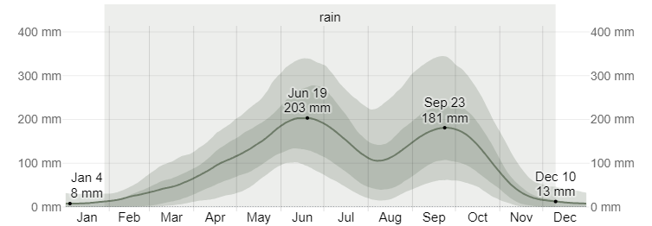

Figure 18: Average Monthly Rainfall in Lagos State Nigeria (Source: Lagos Climate, Weather by Month, Average Temperature (Nigeria) - Weather Spark, n.d.)[5].

### 2.1.4 Rainfall

The rainy season lasts 10 months between January 28 to December 10, with a typical 31-day rainfall of at least 13 millimetres. June is observed to be the wettest month in Lagos, with an average rainfall of 203 millimetres.

The rainless season lasts 1.6 months, from December 10 to January 28. January has the least rain in Lagos, with an average rainfall of 9 millimetres. Lagos State receives an average of 1721.48mm of rain per year (Lagos State Government, Ministry of Environment and Water Resources, 2023).

### 2.1.5 Sun

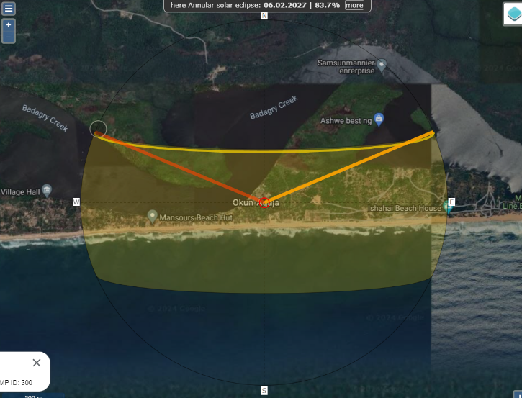The sun plays a crucial role in shaping the climatic conditions at any given location on Earth. For the development of a sustainable hotel or resort, understanding this influence is essential. This knowledge allows us to assess and implement effective strategies for natural lighting, solar heat gains, and solar energy utilization, all of which are vital for creating an environmentally friendly and energy-efficient facility.

Figure 19: Aerial View showing the sun path on the subject site. (Source:(SunCalc Sun Position- Und Sun Phases Calculator, n.d(

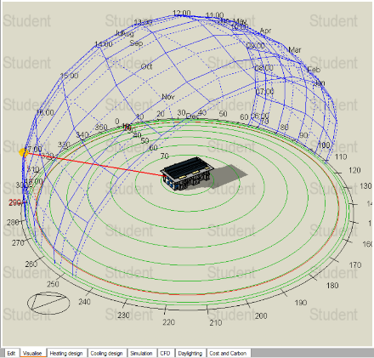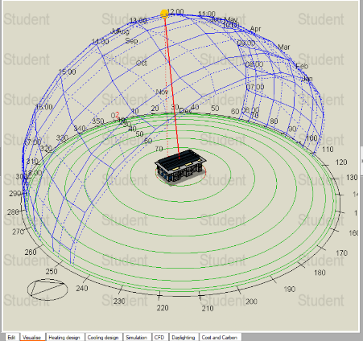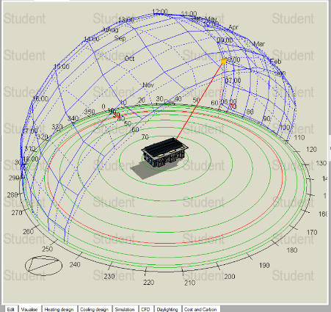

Figure 20: Images showing the simulated sun path on the georeferenced site in design builder for June 21st at 9 am, 12 noon, and 5 pm (left to right). (Source: Design Builder).

The sun rises in the east and sets exactly in the west. At noon the sun is at its highest altitude and its angle can be as high as 90° during the equinoxes (around March 21 and September 23) and lower during the solstices (around June 21 and December 21). Around June 21, the summer solstice, the sun is at its highest point at solar noon, and around December 21, the winter solstice, it is at its lowest point.

Throughout the year, Okun Agaja has a relatively consistent and high level of solar energy due to its proximity to the equator. The region does not experience extreme changes in day length as seen in higher latitudes. On average, each square meter receives over 5.5 kilowatt-hours (kWh) of solar energy daily. The abundance of solar energy is a key factor in the warm and humid climate that characterizes the region (Okun Agaja).

The peak solar energy reception occurs from November to March, with January standing out as the month with the highest solar energy levels, averaging around 6.2 kWh/m2 each day. During this period, the sun is almost directly overhead, which results in more direct sunlight and higher temperatures. This abundance of sunlight supports the lush, tropical vegetation and the bustling activity in the region, (tourism and outdoor activities).

On the other hand, the lowest levels of solar energy are observed from June to September, coinciding with the rainy season. During these months, the average daily solar energy reception falls to around 3.8 kWh per square meter. The frequent cloud cover and rain reduce the amount of direct sunlight reaching the surface. Despite the lower solar energy levels, the region remains warm, and the increased precipitation supports the growth of crops and maintains the verdant landscape.

The consistent and substantial solar energy in Okun Agaja has significant implications for renewable energy potential, particularly solar power. The region's solar energy patterns are conducive to the development of solar energy projects, which can provide a sustainable and reliable source of electricity to support local communities and businesses thereby improving the project's integration with the local society.

### 2.1.6 Daylight Hours and Twilight.

The length of day has little variation throughout the year and typically stays within ±29 minutes of 12 hours (Weather Spark, 2023). The shortest day occurs on the 22nd of December with hours of daylight at 11 hours 45 minutes and the longest day is June 21 with hours of daylight at 12 hours 30 minutes.

`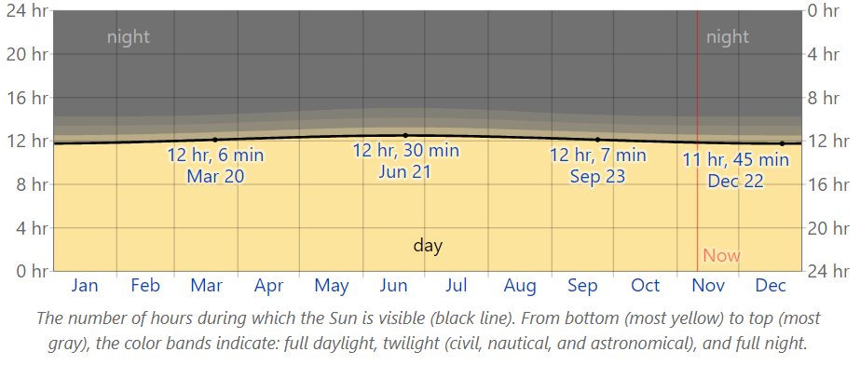

Figure 21:Hours of Daylight and Twilight in Lagos (Source: Lagos Climate, Weather by Month, Average Temperature (Nigeria) - Weather Spark, n.d.)[6].

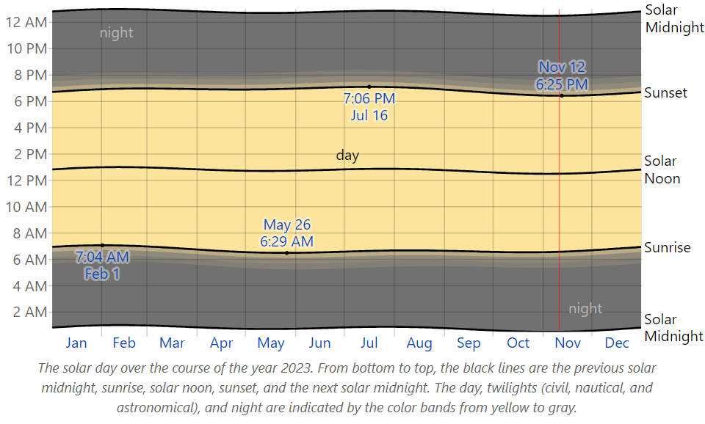

Figure 22:Sunrise & Sunset with Twilight in Lagos (Source: Lagos Climate, Weather by Month, Average Temperature (Nigeria) - Weather Spark, n.d.)[7].

### 2.1.7 Humidity

The dew point, a vital measure of whether perspiration will properly evaporate from the skin, thus altering the body's cooling mechanism, is used to assess humidity comfort. In Lagos, the dew point changes more slowly than the temperature, contributing to a persistent sense of mugginess, particularly during specific seasons.

**Muggy Period**: Lagos has a prolonged muggy period that lasts approximately 11 months, from January 26 to December 26. For at least 88% of the time throughout this period, the comfort level is described as humid, oppressive, or even terrible. May is the month with the muggiest days, with 31.0 days or more.

**Month-to-Month Variation**:

**May - Peak Mugginess**: The month of May is the wettest, with a high number of days classified as muggy or worse.

**January - Lower Mugginess**: In contrast, January has the fewest humid days, totaling 26.6 days or less.

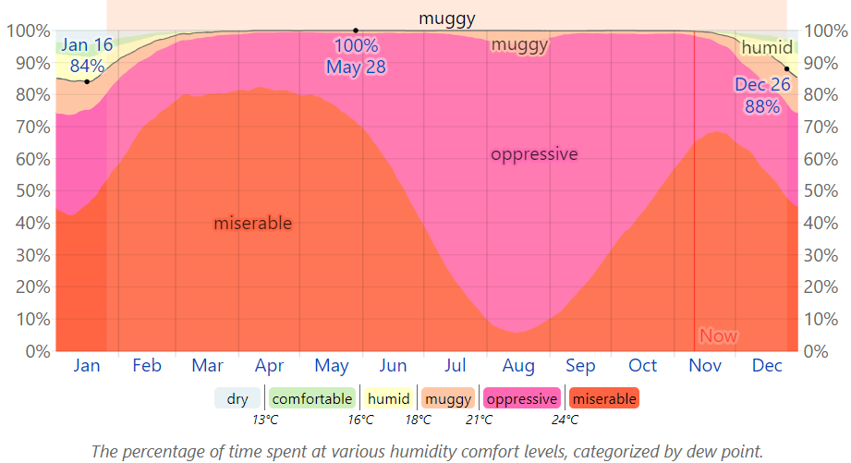

Figure 23: Humidity comfort levels in Lagos (Source: Lagos Climate, Weather by Month, Average Temperature (Nigeria) - Weather Spark, n.d.)[8].

### 2.1.7 Wind

Throughout the year, Lagos has varied wind patterns that are influenced by both regional and local causes. Wind speed and direction help to disperse pollutants, it also influences temperature perception, and add to the general comfort of the place.

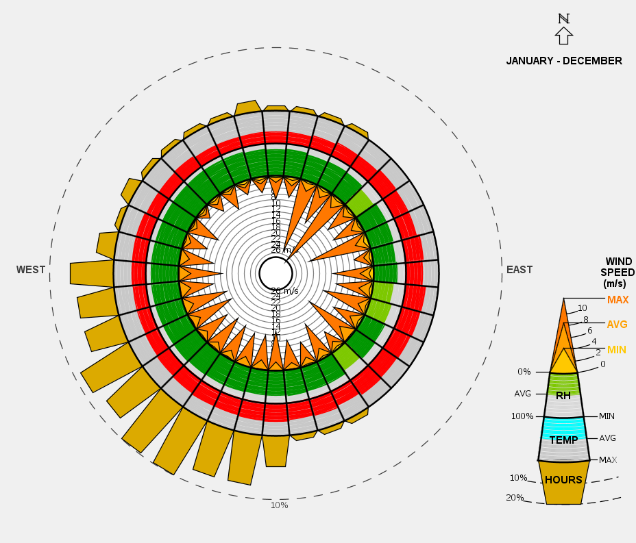

Figure 24: Windrose diagram shows wind direction, speed, temperature and direction in Lagos Nigeria (Source: ClimateConsultant Software).

**Seasonal Changes**

**Windier Period (May 31 to October 9)**: The windier season in Lagos lasts about 4.3 months, from May 31 to October 9. Average wind speeds reach 3.1 meters per second during this period, contributing to a more dynamic atmospheric condition. With an average hourly wind speed of 3.9 meters per second, August is the windiest month.

**Less Windy Period (October 9 to May 31)**: The calmer season lasts approximately 7.7 months, from October 9 to May 31. Wind speeds are often lower during this period, giving a more peaceful atmosphere. December is the calmest month, with an average hourly wind speed of 2.1 meters per second.

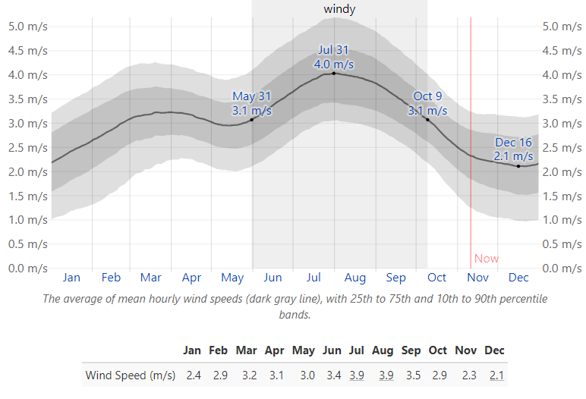

Figure 25:Wind Speed in Lagos, Nigeria Source: Lagos Climate, Weather by Month, Average Temperature (Nigeria) - Weather Spark, n.d.)[9].).

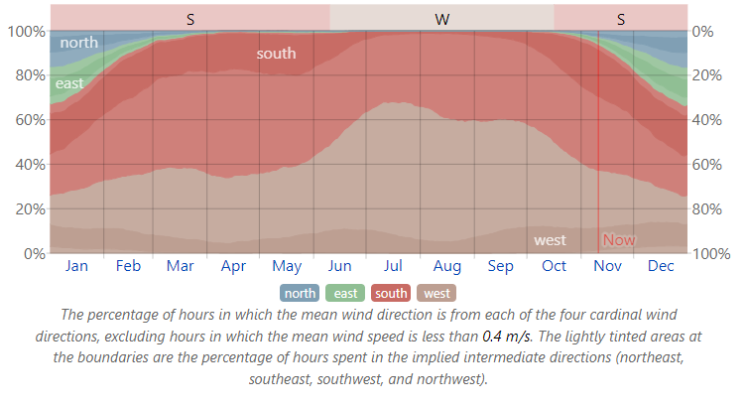

Figure 26:Wind Direction in Lagos, Nigeria Source: Lagos Climate, Weather by Month, Average Temperature (Nigeria) - Weather Spark, n.d.)[10].

## 2.2 Topographical Analysis of Site

The elevation profile of the beachfront property shows a modest variation in height, with the highest point reaching approximately 20 feet above sea level and a steep drop in height of about 12ft at the coastal line border of the site. This relatively gentle slope indicates a site that is not excessively steep but still offers some variation in elevation, which is advantageous for a tourism infrastructure development of this nature.

**Topographical Features:**

**Elevation Variation:**

The elevation ranges from sea level up to about 20 feet. This provides a natural gradient that can be utilized for scenic views of the sea and surrounding nature without bringing about significant challenges for construction.

The presence of an elevated view of the sea, as indicated by the depression in the profile, enhances the visual appeal and potential for creating desirable tourist destinations.

**Scenic Views:**

The elevated areas offer unobstructed views of the ocean, making them prime locations for structures that can capitalize on scenic vistas, such as restaurants, observation decks, and luxury accommodations. This can significantly enhance the appeal and property's marketability as well as attractiveness to tourists.

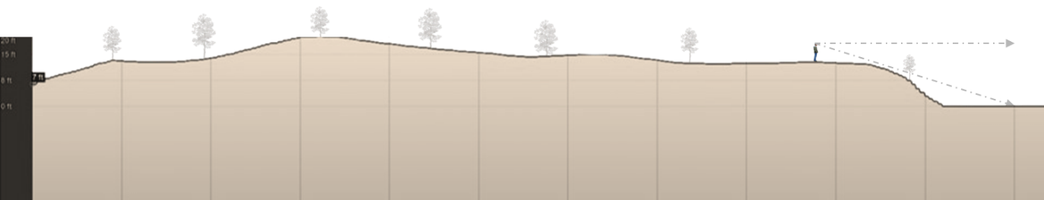

Figure 27: Section Through the site showing its elevation. Source: Google Earth

**Drainage and Flood Management:**

The topographical nature of the site, offers effective site drainage opportunities, helping to manage rainwater runoff and reduce the risk of flooding, which is crucial in coastal areas.

The depression in the profile can serve as a natural drainage basin, which can be integrated into the site design for stormwater management.

**Accessibility and Development Ease:**

The gentle slopes across the property make it easier to construct infrastructure, such as roads and pathways, jogging or cycling routes without extensive grading or earthworks.

The elevation variation is mild enough to ensure accessibility for all, including individuals with mobility challenges, by implementing gradual ramps and gently sloping pathways.

**Vegetation and Landscaping:**

The site’s topography supports a variety of vegetation types, which can be used to enhance the landscape and contribute to ecological sustainability. Native coastal plants can be strategically placed to stabilize the soil, provide windbreaks, and enhance the overall aesthetic of the property.

**Recreational Opportunities:**

The beachfront location combined with the gentle slope makes it ideal for various recreational activities such as beach volleyball, outdoor dining, and scenic walks. Elevated areas present an opportunity for development into vantage points for sightseeing and photography, adding to the tourist experience.

Write about the influence of microclimatic factors around the beach on the site.

## 2.3 Psychrometric Analysis

The Psychrometric analysis examines the interaction between environmental conditions and human comfort to enhance the thermal comfort of tourist or facility users. Therefore the section below details the output of the psychrometric analysis carried out using historical weather data obtained from the weather station at Lagos International Airport (DNMN). The understanding and integration of key factors such as temperature, humidity, and ventilation was pivotal in the optimization of design for energy efficiency.

### 2.3.1 Givoni Bioclimatic Chart.

The Givoni Bioclimatic Overlay Chart gives an intuitive analysis of the climatic conditions in Okun Agaja, Lagos, Nigeria, focusing on the interaction between temperature and humidity. The dry bulb temperature observed ranges from 20°C to 45°C, and relative humidity varies notably between 20% and 100%. The chart highlights the comfort zone, which is found between approximately 22°C and 30°C for dry bulb temperature and 40% to 60% relative humidity.

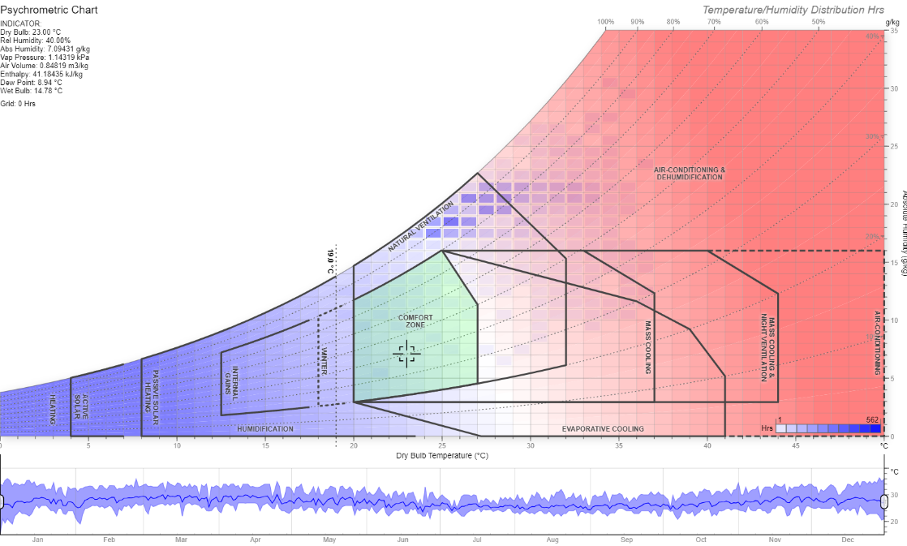

Figure 28: Givoni Overlay Bioclimatic Psychrometric chart (Source: (Dr.A.J.Marsh, 2024)[11]

To maintain comfort within this range, several strategies would be employed:

**Natural Ventilation**: This can be utilized for most part of the year, especially when temperatures are below 30°C. Natural ventilation proves a cost-effective method to significantly enhance indoor air quality and thermal comfort in the local climate without relying heavily on mechanical systems.

**Evaporative Cooling:** This proves as an effective method when temperatures exceed 30°C and humidity is relatively low. This can help reduce temperatures and maintain comfort in hot, dry conditions. This would be achieved through open-air designs and materials that retain moisture as well as fountains, trees, green walls and green roofs e.t.c.

**Dehumidification:** this is utilized to bring down 60%, and the temperature is above 25°C. Dehumidification can help manage indoor air quality and avoid discomfort due to high moisture levels.

**Heating:** this is rarely needed as temperatures recorded in the region are generally high.

**Work Heat Index Chart Analysis**

The Work Heat Index overlay was used to evaluate the potential for heat stress based on temperature and humidity. The analysis carried out revealed several key zones of concern and these are highlighted below:

* **Extreme Caution Zones**: These begin around 30°C combined with higher relative humidity.
* **Danger Zones**: These occur around 35°C and higher humidity levels.
* **Extreme Danger Zones**: These exceed 40°C with high humidity.

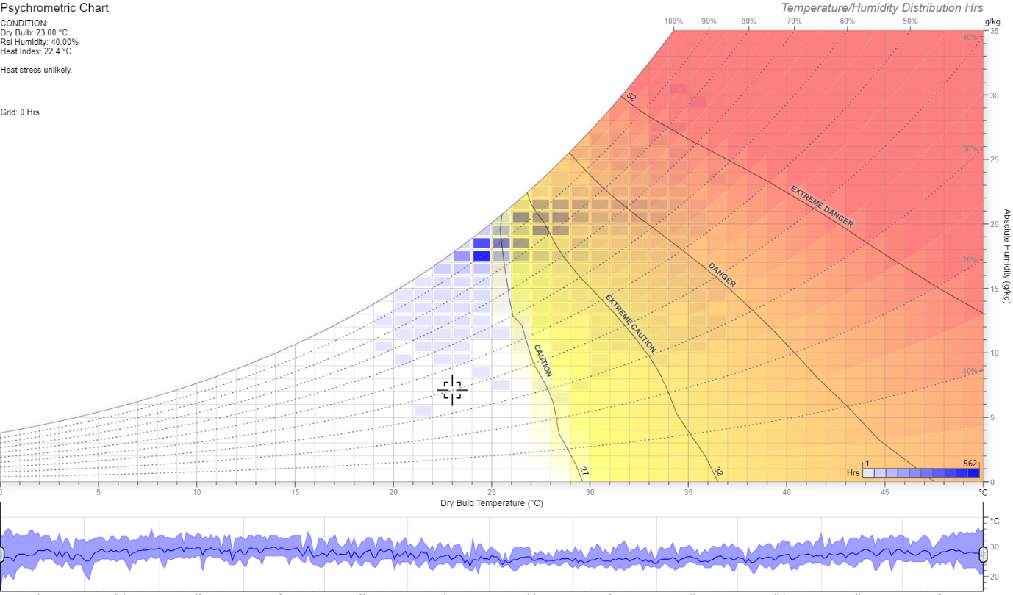

Figure 29: Psychrometric chart with heat Index Overlay (Source: (Dr.A.J.Marsh, 2024)[12]

To manage the heat index and mitigate heat stress, several strategies were implemented:

* **Shading**: Ample shading devices were provided through structures, sunscreen, vegetation, or canopies as these significantly reduce heat exposure.
* **High Reflective and emissive Materials**: the design utilizes materials with high SRI for roofs to help lower the overall heat absorption of buildings,
* **Adequate Hydration**: Users would have access to drinking water and stay hydrated through the provision of ample water dispensing units.

**Good Airflow:** The design aims to improve airflow using mechanical fans or natural ventilation to help dissipate heat and improve comfort. The improved comfort is to be achieved through increased airspeed and heat transfer via convection and evaporation which brings about a cooling sensation (evaporative cooling).

**PMV (Predicted Mean Vote) Overlay Chart Analysis**

The PMV Overlay provides a detailed prediction of thermal comfort, utilizing the Predicted Mean Vote (PMV) index. The analysis shows:

**Comfort Prediction**: PMV values range from slightly cool to slightly warm conditions, with values around 0.69 indicating slight discomfort. The comfort zone for PMV, with values between -0.5 and 0.5, aligns with dry bulb temperatures from approximately 22°C to 28°C and relative humidity from 30% to 60%.

**Compliance:** The current conditions indicate non-compliance with ASHRAE 55-2017 standards, which is the basis for the need for improved thermal comfort management.

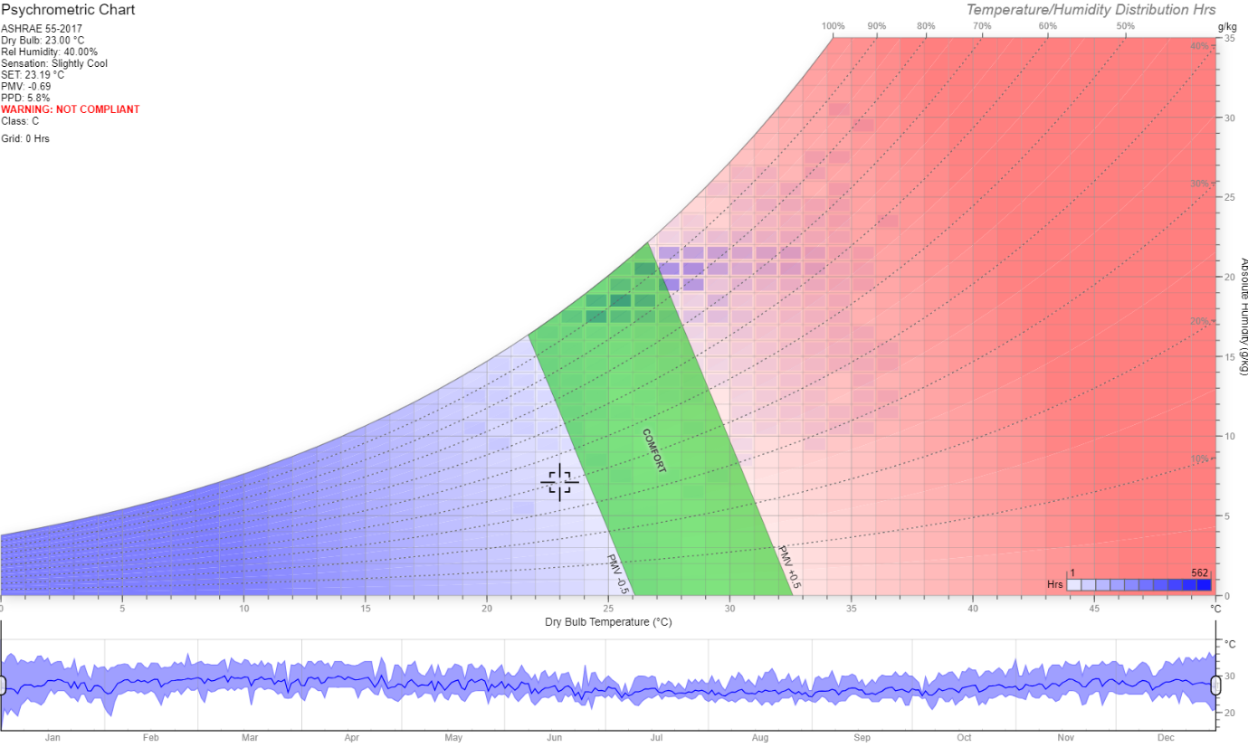

Figure 30: Psychrometric chart with ASHRAE 55-2017 overlay Source: Dr.A.J.Marsh, 2024)[13].

The heat index is crucial for activities done in an outdoor environment, as this helps in assessing the risk of heat stress and taking appropriate preventive measures to avoid harm to tourist or facility users. These measures include providing shade, implementing hydration strategies, scheduling breaks, and adjusting work hours or specific facility use to avoid the peak heat of the day.

The Psychrometric chart above in Figure 30 shows that environmental conditions in Lagos state Nigeria could cut across several zones from normal or comfortable conditions to dangerous levels. This observation derived from the above analysis led to a design decision to ensure that outdoor spaces where tourists would have activities be provided with adequate shading/cooling elements to reduce the incidence of heat-related sicknesses or diseases among facility users and staff. Outdoor water dispensers and or sprinklers would also be provided within these areas to ensure adequate hydration of persons.

## 2.4 Climate Adaptation Measures / Concepts.

This section explores strategic approaches in the domain of “Climate Adapted concepts” for the tourism facility (resort centre) in Okun Agaja, Lagos Nigeria. This is pivotal in the design strategy for the proposed facility in Okun Agaja, Lagos Nigeria. This approach acknowledges the impact/influence of climatic variables on architectural endeavours, this design strategy meticulously explores adaptive design principles tailored to integrate seamlessly with the distinctive climate of Lagos. These strategies are borne out of evidence-based methodologies and sustainable principles with the objective of bringing about a wholesome environment that ensures seamless integration with the local climate while championing energy efficiency, occupant well-being, and the total efficiency of the facility.

The climate-adaptive strategies laid out below also take into account the psychrometric and climatic data and proffers solutions/strategies to allow facility users to attain and maintain comfort throughout the use of the facility. These strategies which integrate passive design principles ensure the design responds adequately to the local weather conditions ranging from mild to extreme.

The

Table 3: Table outlining the several climate based design strategies to be implemented in the resort facility.

|  |  |  |
| --- | --- | --- |
| Strategy | Solution | Climate-Based Evidence |
| **Use of Natural Ventilation.** | * Proper Shading of windows. * Proper orientation to prevailing winds/breezes. * Use of Operable windows (Louvres) that enable maximum infiltration of natural winds. * Use of wingwalls, plants and landscaping to naturally change wind direction to a tune of ≤ 45° towards the building. * Use of Long Narrow building floorplan as well as positioning doors and windows on opposite sides of building with larger windows facing up-wind to allow for cross-ventilation. * Use of open plans to facilitate free movement air within the building. | The tropical climate of Lagos experiences high temperatures and humidity, necessitating effective cooling strategies.  Cross-ventilation is critical in hot, humid climates to promote air movement and reduce indoor temperature.  The prevailing southwest monsoon winds in Lagos can be harnessed for natural ventilation. |
| **Building Orientation and Layout.**  Aim is to maximise exposure or infiltration of natural lighting, wind through optimized building positioning and orientation thereby reducing energy usage within the building. | * Longer walls of building are to be north and south facing to minimize direct solar gain on the east and west walls, reducing cooling loads. | Aligning buildings with longer sides facing north-south thereby minimizing exposure to the harsh morning and evening sun which helps in managing heat gain.  building orientation optimization maximizes natural daylight and airflow, thereby reducing energy consumption in lighting and cooling. |
| **Passive Solar Design** | * Use of window & door overhangs or sunshades (awnings) to prevent direct sunlight while allowing diffused light thereby reducing solar heat gains. * Use of adjustable louvered shutters to regulate sunlight penetration into the building thereby providing flexibility based on user preference, time of day and season. * Roof Insulation to prevent solar heat penetration into building and also use of materials with high SRI (Solar reflective index) or light coloured materials (cool roofs) to reflect solar radiation. * Use of Materials with high thermal mass such as concrete or brick to absorb heat during the day and releasing the heat at night thereby helping to regulate the indoor temperature. * Use of double glaze windows along with reflective or low emissivity coatings to reduce heat gained while maintaining visibility and natural light. * Use of high albedo (reflective) materials for building exteriors to reduce heat absorption. * Use of double roofs to help ventilate roofs or provision of ventilated roof spaces to allow the escape of hot air and reduce heat transfer to interior. * Installation of pergolas and trellises with climbing plants to create shaded outdoor spaces. | The intense solar radiation observed in Lagos makes it necessary to adopt shading and reflective strategies to reduce cooling loads  - The use of high thermal mass materials help to stabilize indoor temperatures in climates with high diurnal temperature variations.  The use of cool roofs and reflective materials reduces the heat island effect. |
| Landscaping | * Provision of trees (deciduous) which act as shades on the east and west facing walls to provide shade during hot months and allow sunlight during the cooler months * Integration of green roofs help in provision of insulation as well as reduce the heat island effect and improve air quality. It also helps in enriching the biophilic ecosystem of the facilities. | Deciduous trees provide seasonal shading, which in tropical climates helps to manage solar gain and reduce indoor temperatures.  Green roofs are efficient in tropical climates for reducing rooftop temperatures and improving insulation, thereby lowering cooling energy demand. |
| Indoor Plants | * indoor plants that naturally dehumidify the air, such as peace lilies and Boston ferns. | High humidity levels as shown in climatic studies above (see section 2.1.7) make dehumidification necessary to attain indoor comfort, and plants such as peace lilies and Boston ferns can naturally help in reducing indoor humidity. |
| Water Features | * Installation of water features such as ponds or fountains near building entrances and courtyards to cool the air through evaporation. | Evaporative cooling is highly effective in hot climates like Lagos, where water features can significantly reduce surrounding air temperatures. |
| Water Management | * Rain-water Harvesting: Installation of rain water collection or harvesting systems to retrieve and store for later usage as non-portable water. * Use permeable paving materials to reduce runoff and increase groundwater recharge. | heavy rainfall (avg. 1721.48mm/year) is observed in Lagos Nigeria, and this makes rainwater harvesting an effective strategy to reduce dependency on municipal water supply and help in the management of stormwater.  Permeable pavements are essential to manage heavy rainfalls and prevent flooding. |
| Building Materials | * Utilization of breathable walls whose materials allow moisture to pass through thereby preventing the build up of moisture. For this purpose, clay bricks have been selected and they are also available abundantly in the local context. | Lagos has a high average humidity level, often exceeding 80%, which can negatively impact thermal comfort by making it harder for sweat to evaporate and cool the body.  The use of breathable materials prevent moisture accumulation and reduce the risk of mold and mildew, improving indoor air quality.  Clay bricks are locally available and suitable for tropical climates due to their thermal and moisture-regulating properties. |
| Renewable Energy | * Utilization of photovoltaic panels to generate electricity, taking advantage of the abundant sunlight in Lagos | Lagos receives about 1,800 to 2,200 hours of sunshine annually, providing ample solar energy potential (SolarGis, 2021).  The average solar insolation in Lagos is approximately 4.5-5.5 kWh/m²/day, making solar photovoltaic systems a highly effective solution for renewable energy generation and reducing reliance on non-renewable power sources (NASA Surface Meteorology and Solar Energy Data Set, 2021; Renewable Energy Resource Assessment, 2018; "Photovoltaic Geographical Information System (PVGIS)," European Commission, Joint Research Centre). |

**Implementation of climate based strategies in the Resort design.**

This sections seeks to highlight and visualize the implementation of the above strategies in the design.

### 2.4.1 Building Orientation and Layout.

The main objective of this climate-based design concept is to minimize solar heat gain and promote ventilation through cross and stack ventilation methods. This also places a focus on the influence of building layout and orientation on the infiltration of natural daylight into the building. Within this strategy, the following design objectives are implemented.

**Elongation of Building blueprint in the east-west direction (Longer North and south-facing walls)**: This allows for the optimal utilization of site energy flows. With the elongation in the east-west direction, there is reduced solar heat gain on the east and west walls due to the short span / duration (morning and evening sunshine). This elongated form also optimizes for increased exposure to prevailing winds.

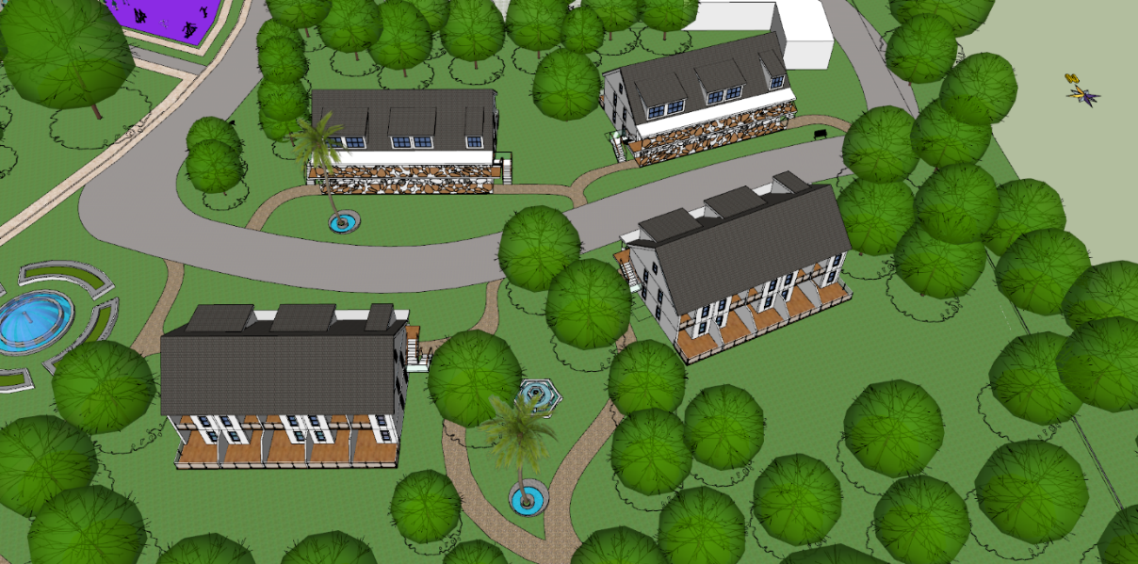

Figure 31:Building Orientation (source: Author)

**Narrow Floor Plate:** The buildings are designed to have narrow footprints, promoting the efficient movement of air through the building thereby allowing for cross-ventilation through optimized placement of doors and windows. This strategy provides numerous benefits such as the enhancement of indoor air quality, reduction in the reliance on mechanical ventilation thereby reducing energy cost. Furthermore, this optimizes the building for natural daylighting thereby improving productivity, enhancing moods as well as improving sleep patterns.

### 2.4.2 Natural Ventilation.

Observation/results from the Psychrometric analysis shows that natural ventilation is a potential mitigation strategy for the availing negative environmental conditions. The design achieves this through optimal building orientations which allows for the utilization of prevailing wind, cross and stack ventilation strategies, and the use of fins or louvred windows to influence and direct the flow of wind. As seen in the climatic analysis the prevailing wind in the region is the south-west monsoon wind, and this is used in the placement and orientation of the design to ensure windows capture the maximum amount of wind.

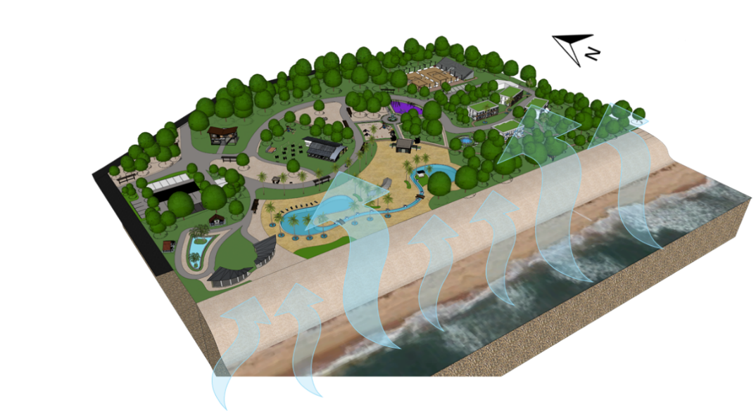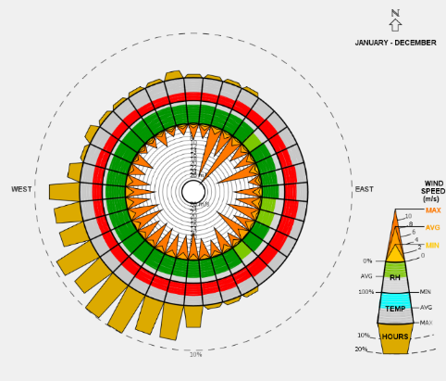

Figure 32:Image showing direction on wind in relation to site context (Source: Author)

### 2.4.3 Daylighting and shading.

The project has an aim to integrate biophilic elements and principles into the design, therefore the design places an emphasis on the utilization of natural daylight within building spaces not only for energy efficiency but for its biophilic benefits also the strategies utilized for optimizing north glazing to improve natural daylighting in a structure are outlined below. To limit solar heat gain, the emphasis is on optimal building orientation, stretching the structure east-west, and employing shading measures for west-facing walls. Shading measures include

* Awnings
* Pergolas
* Trees or landscape features
* overhangs

The narrow form also allows for direct and diffuse light to properly permeate through the building spaces, ensuring an even spread of daylight within the building. Additionally, it simplifies the integration of shading elements on the west and east facing side.

### 2.4.5 Cool Roofs & Double Roofs.

Cool roof are roofs intended to reflect more sunlight and absorb less heat than standard roofs, making them an efficient technique for heat mitigation in hot regions such as Lagos, Nigeria. Cool roofs possess numerous benefits for energy efficiency, indoor comfort, and overall sustainability in a climate-based design for Lagos, where solar irradiance is typically high throughout the year.

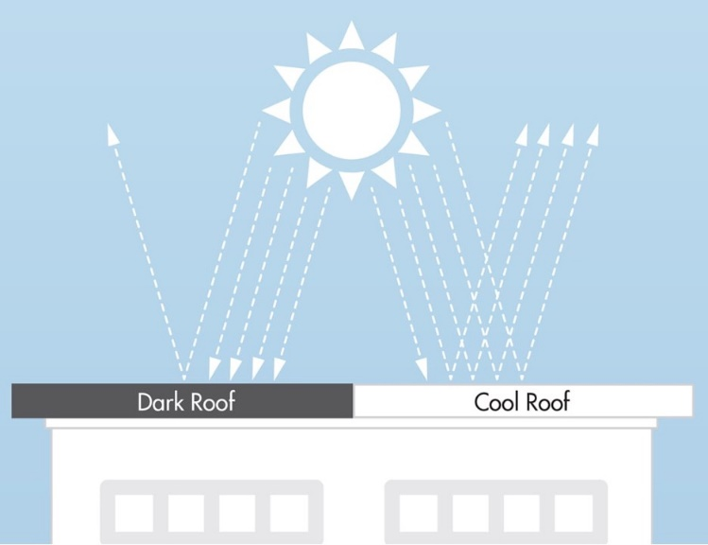

Figure 33: Illustration showing the reflectance of sunlight in cool roof vs dark roofs. (Source: gaf.com/en-us/blog/six-truths-about-cool-roofs-28147498010538)

These roofs have high solar reflectance indices (SRIs), a measure of a roof's capacity to reflect solar heat that combines the reflectivity and emissivity characteristics of the roof.

**Benefits of cool roofs within the local context.**

**Enhanced energy efficiency**: Cool roofs limit solar heat absorption, which lessens the amount of heat that enters the building and, consequently, lowers the amount of cooling energy needed to maintain ideal thermal conditions.

**Increased Thermal Comfort:** Lower inside temps are maintained with the help of cool roofing. Additionally, cool roofs reduce the impact of the urban heat island, particularly in crowded urban areas like Ajah, Lagos, Nigeria.

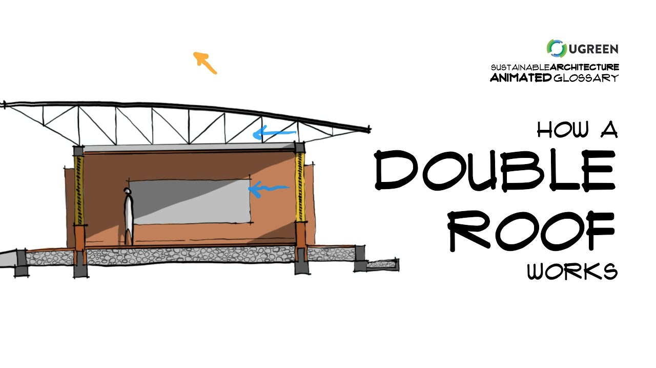

Figure 34:Illustration showing a double roof (Source: Ugreen).

Air Gap

Air Flow

### 2.4.6 Double roofs

Double roofs feature two layers separated by an air gap and this offers notable advantages in building design. The air gap acts as effective insulation as this provides for adequate barrier impeding the transfer of heat from the first roof layer to the building, thereby providing increased thermal efficiency, energy savings, and improved indoor comfort. This design promotes sustainability by reducing the building's carbon footprint and enhances overall structural longevity by controlling moisture. In essence, double roofs are a practical and eco-friendly solution for optimizing the thermal performance of buildings

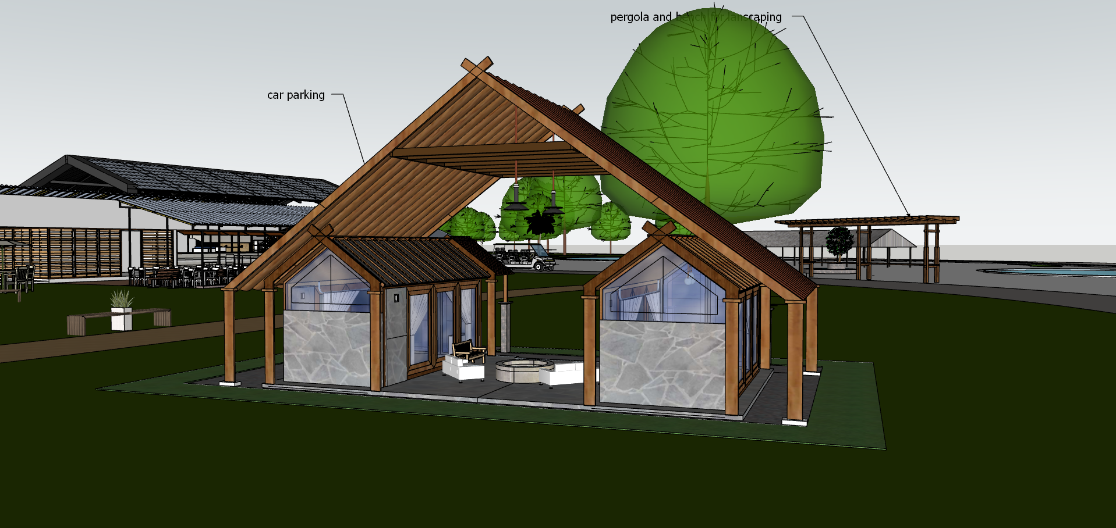

Figure 35 : Excerpt from design showing the implementation of double roofs in the massage and spa rooms. (Source: Author).

### 2.4.7 Green Roofs.

These are also called vegetative or living roofs and form an integral component of the sustainable resort design. Green roofs as they are commonly called offer a wide range of benefits spanning the environmental, economic and social areas. The design incorporates green roofs as a sustainable component primarily to enhance thermal regulation & energy efficiency, improve air quality, Noise reduction, reduce urban heat island effect, and provide aesthetically pleasing and functional spaces that align with biophilic design principles.

The design utilizes extensive green roof system which allow for a shallow soil depth, lightweight plants and require minimal maintenance with the use of drought resistant plants.

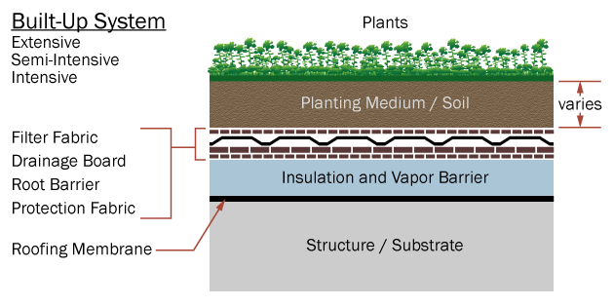

Figure 36:Cross-sectional diagram of a green roof system, detailing the layers involved, including the vegetation, soil, drainage, and waterproofing layers (Bridge.mp4, 2021)[14].

## 2.4.8 Green Spaces:

As stated in the design goals section, the project aim to ensure facility users fully immerse in the authentic experience of nature rather than placing a focus on man made environments or buildings. Therefore the design incorporates ample green outdoor spaces, trees , plants etc. thereby mitigating the impacts of humidity and heat. Trees and vegetation help in air quality enhancement and also have a positive impact on the reduced absorption of heat, creating an ideal microclimate not only for the outdoor environment but also the indoor spaces. The green area also provide aesthetic as well as biophilic benefits such as lowered blood pressure, improve mental engagement and overall mood enhancement (14 Patterns of Biophilic Design, 2014)[15]. The green spaces which also double as unsealed surfaces also aid in storm water management during and after rainfalls. Unsealed surfaces reduce storm water run off through the permeation of storm water into the ground thereby reducing the build up of flooding. Utilizing LEED 4.1 as a guidance in the development of the project, the protection of a minimum of 40% greenfield area was also achieved as well as the use of native plant species in the landscaping to attain points in the Sustainable Sites (Site Development – Protect or Restore Habitat) criteria.

The LEED v4.1 requirement for Site Development – Protect or Restore Habitat specifies that projects must protect 40% of the greenfield area or restore 30% of the site with native or adapted vegetation.

**Project Site Area**: 54,000 m²

**Protected Greenfield Area**: 26,479 m²

**Calculation**:

* **Required Protected Greenfield Area** (40% of total site area):

40%×54,000 m2=21,600m2

* **Actual Protected Greenfield Area**:

26,479 m2

The project has successfully protected 26,479 m² of the site, which is greater than the required 21,600 m². Therefore, the project meets the LEED v4.1 requirement for protecting 40% of the greenfield area.

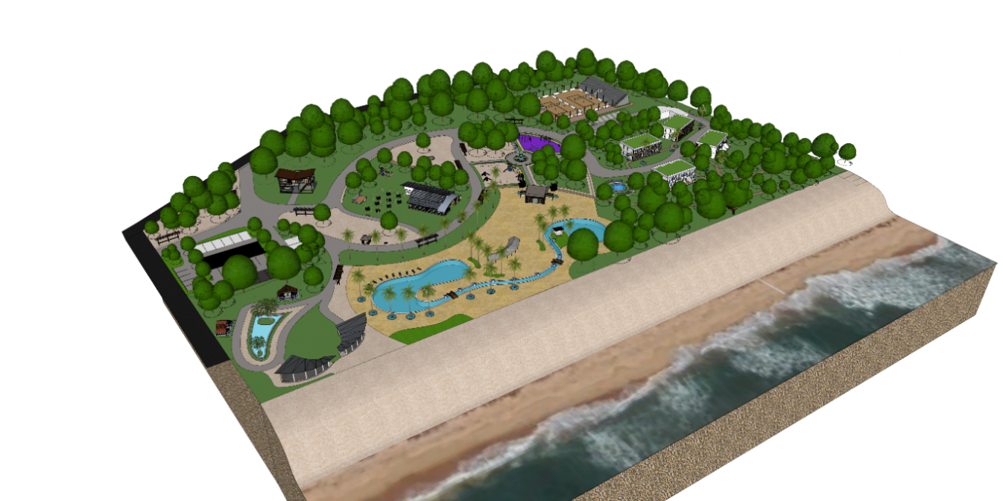

Figure 37: Layout showing the beautiful greenery and landscape integrated into the site design.

## 2.5 Description of Spaces:

The sustainable tourism facility is designed with well-planned rooms and spaces tailored to meet the diverse needs of both local and international tourists. The design carefully considers the allocation and dimensions of each space to enhance functionality, connectivity, and the overall well-being of guests. This facility caters to the needs of both day guests and overnight guests, ensuring comfort and convenience for those staying for a short visit or an extended period.

The design adheres to relevant standards and guidelines to ensure that all safety and quality requirements are met. These include:

* **Neufert Architects' Data**
* **National Building Code of Nigeria (NBC)**
* **Guidelines for Hotels and Guesthouses** by the Nigeria Tourism Development Corporation (NTDC)
* **Planning and Design Standards for Small Hotels and Resorts** by the International Finance Corporation (IFC), as outlined in the "IFC Performance Standards on Environmental and Social Sustainability" (2012)
* **Sustainable Building Design Manual** (n.d.)

These standards ensure that the facility is not only compliant with national regulations but also aligns with international best practices for sustainability and safety. Each space within the facility is designed to optimize guest experience, ensuring that all visitors, whether staying for a few hours or several days, have a memorable and comfortable experience.

The table below shows the design specifications for various spaces within the facility. The zones are divided into Guest, Wellness & Recreational Area, Catering Area, Administration Area, and Outdoor Spaces. Each zone encompasses different spaces with varying design specifications. As an example the Guest zone which has Double Rooms has specifications for a Double Room with a minimum size of 22.5m2, with details for a 4-star luxury hotel room extracted from Neuferts Architects Data (p. 172). It also shows the total area utilized for each space where this can be calculated.

Other spaces in the table have design specifications that include the number of people the space can accommodate and the total area. For example, the Swimming Pool can accommodate 20 people and has a total area of 80 square meters.

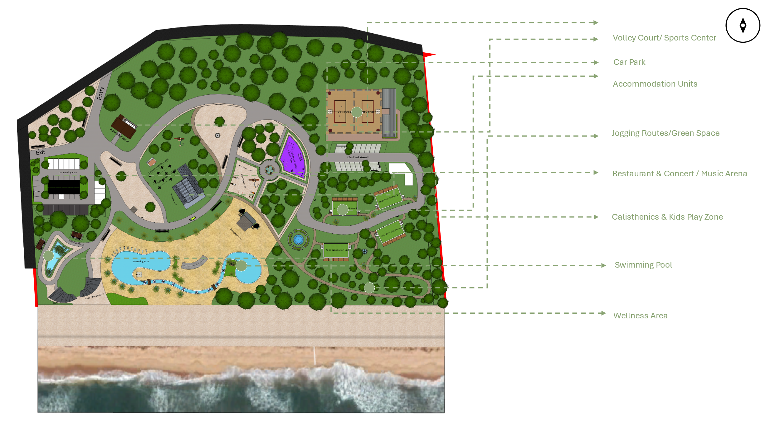

Figure 38: simple graphic depiction of spaces using site plan (Source: Author).

Table 4:Table showing list of zones and affiliated spaces as well as design standards.(Source: Author)

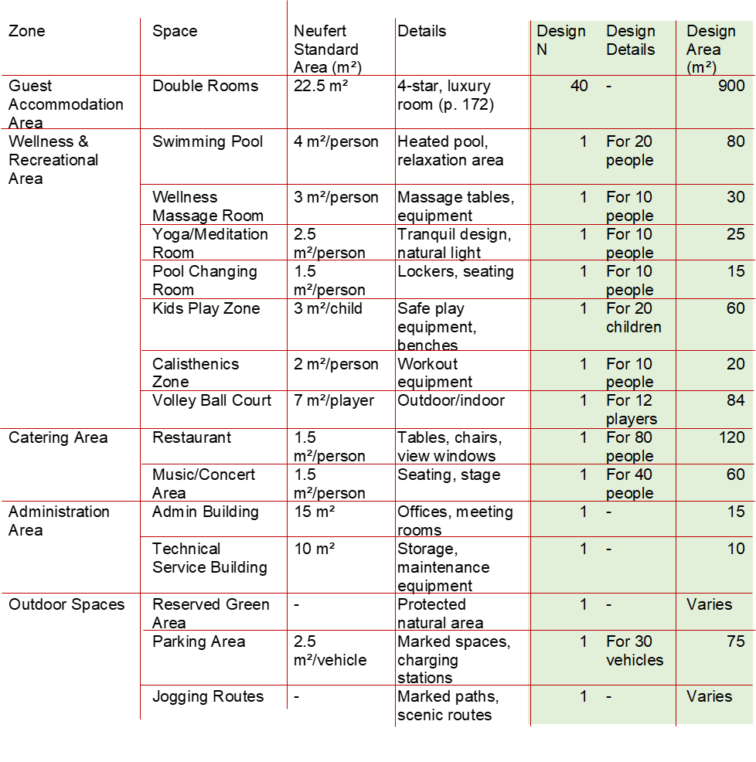

### 2.5.6 Overview Of Spaces.

**Guest Accommodation Area**

**Double Rooms:** Each double room is designed as a 4-star luxury space, offering a comfortable stay with premium bedding, a private bathroom, and modern furnishings. With 40 rooms available, totaling 900 m², this area provides guests with a relaxing and high-quality accommodation experience. The luxurious setting enhances guests' comfort and provides a serene environment for rest and rejuvenation, making it an ideal retreat for tourists.

**Wellness & Recreational Area**

**Swimming Pool:** The resort features a heated swimming pool with a relaxation area, designed to accommodate 20 people within an 80 m² space. The heated pool ensures a comfortable swimming experience year-round, while the relaxation area provides a serene environment for unwinding. This facility promotes physical well-being and relaxation, crucial for tourists seeking stress relief and leisure (Tinsley & Eldredge, 1995)[16].

**Wellness Massage Room:** This tranquil 30 m² space, equipped with massage tables and essential wellness equipment, is designed for 10 people. Guests can indulge in therapeutic massages that alleviate stress and tension, promoting overall well-being. The serene ambiance enhances the relaxation experience, offering a perfect escape for those seeking rejuvenation (Field, 2014)[17].

**Yoga/Meditation Room:** A calm, serene 25 m² room designed for yoga and meditation, accommodating 10 people. With natural light and tranquil decor, this area enhances guests' mindfulness practices. The peaceful environment aids in mental relaxation and stress reduction, catering to tourists looking to rejuvenate their minds and bodies (Wahbeh, Elsas, & Oken, 2008)[18].

**Pool Changing Room:** Equipped with lockers and seating, the 15 m² pool changing room provides convenience for 10 pool users. This facility ensures guests have a comfortable and secure place to store their belongings and prepare for swimming, enhancing their overall experience at the pool.

**Kids Play Zone:** A safe and engaging 60 m² area with play equipment and benches, designed for 20 children. This space ensures young guests have a fun and secure place to play, allowing parents to relax knowing their children are entertained in a safe environment. It promotes physical activity and social interaction among children, making it a family-friendly feature (Frost, 1992)[19].

**Calisthenics Zone:** An outdoor workout area spanning 20 m², featuring calisthenics equipment designed for 10 people. This zone promotes physical fitness and outdoor exercise, providing guests with an opportunity to maintain their fitness routine while enjoying the fresh air. It encourages an active lifestyle, which is beneficial for health-conscious tourists (Thompson Coon et al., 2011)[20].

**Catering Area**

**Restaurant:** The resort's restaurant, covering 120 m², offers seating for 80 people. It features tables, chairs, and view windows, providing a pleasant dining experience with scenic views. The diverse menu and comfortable seating enhance the dining experience, making it a key attraction for guests looking to enjoy delicious meals in a beautiful setting.

**Music/Concert Area:** A versatile 60 m² space for musical performances and concerts, accommodating 40 people. It includes seating and a stage, enhancing the cultural and entertainment offerings of the resort. This area provides guests with an opportunity to enjoy live music and performances, enriching their cultural experience during their stay.

**Administration Area**

**Admin Building:** This 15 m² building houses offices and meeting rooms, providing a centralized location for management and administrative functions. The well-organized space ensures efficient operations, contributing to the smooth running of the resort, which directly impacts guest satisfaction.

**Technical Service Building:** Designated for storage and maintenance equipment, this 10 m² facility ensures the efficient upkeep and operation of the resort's infrastructure. This behind-the-scenes functionality supports the overall guest experience by maintaining high standards of cleanliness and functionality throughout the resort.

**Outdoor Spaces**

**Reserved Green Area:** A protected natural area dedicated to conservation and relaxation. This space offers guests a serene outdoor environment to enjoy nature. The natural beauty and tranquility of the green area provide a peaceful retreat, promoting mental well-being and offering a scenic spot for leisurely walks and relaxation (Kaplan & Kaplan, 1989)[21].

**Parking Area:** The resort provides parking for 30 vehicles, covering 75 m². The parking area includes marked spaces and charging stations for electric vehicles, ensuring convenience for guests. This feature supports eco-friendly practices and provides easy access for those traveling by car, enhancing overall convenience.

**Jogging Routes:** Marked paths and scenic routes designed for jogging and walking. These areas promote outdoor physical activity and enjoyment of the natural surroundings. The scenic routes offer guests an opportunity to explore the beauty of the resort grounds while staying active, contributing to both physical and mental health (Miller, 2006)[22].

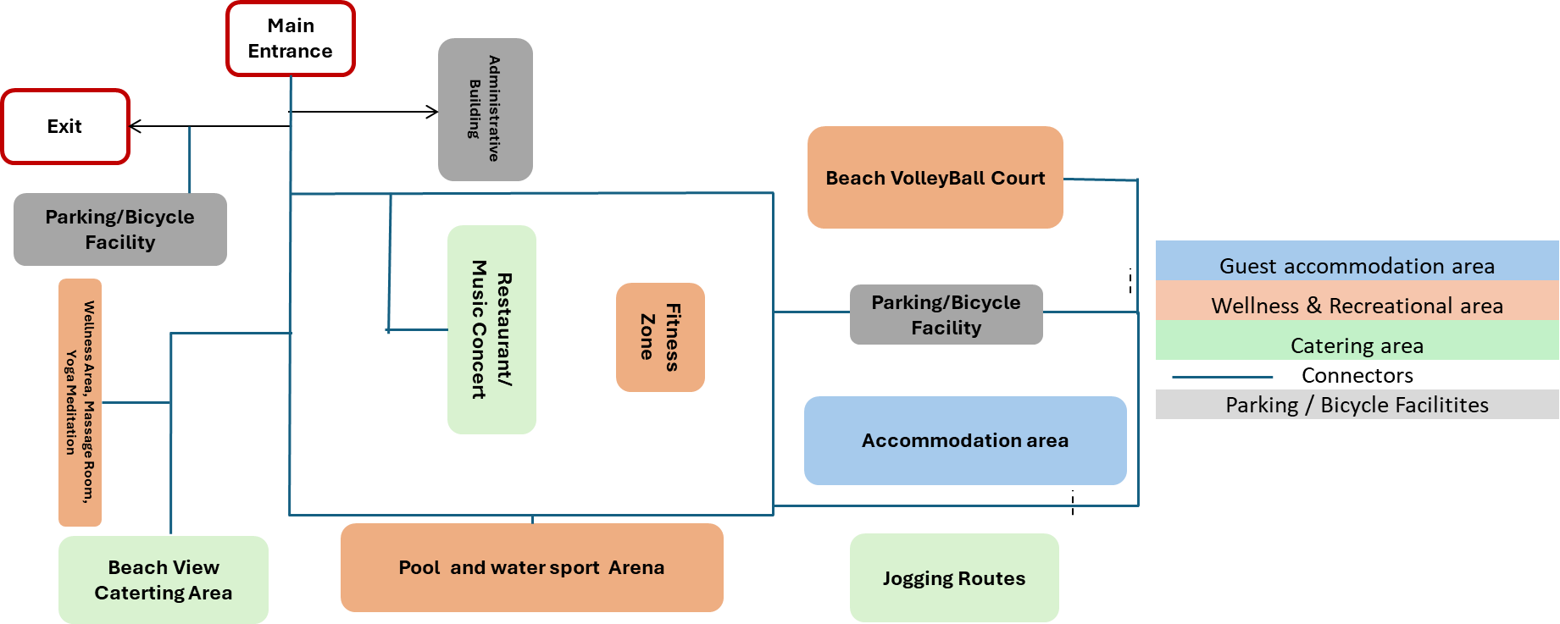

Figure 39:Simple Organisational Chart of the Resort Design (Source: Author).

## 2.6 Resort Design Concept

The hospitality industry is evolving and has begun to embrace sustainable practices that benefit the environment, local communities, and the overall guest experience. This section outlines the conceptual framework for the resort which has been designed with biophilic principles integration and a focus on rural tourism to enable the attainment sustainable hospitality. The organizational chart and site plan as outlined above emphasize integration with nature, community involvement, and environmentally friendly practices.

### 2.6.1 Organizational Structure and Site Plan

The hotel’s organizational structure and site plan are thoughtfully designed to support a holistic approach to sustainability. At the helm of the hotel is the administrative building, serving as the hub for operational management and administration. This node serves as the connector to the various facilities that cater to the diverse needs of guests.

The restaurant and music concert venue serve as a cultural connection, which offer a unique dining and entertainment experience that fosters cultural exchange. As an example, is the collaboration with local performing artist to entertain guest which visit the facility thereby increasing the potential as a tourist attraction.

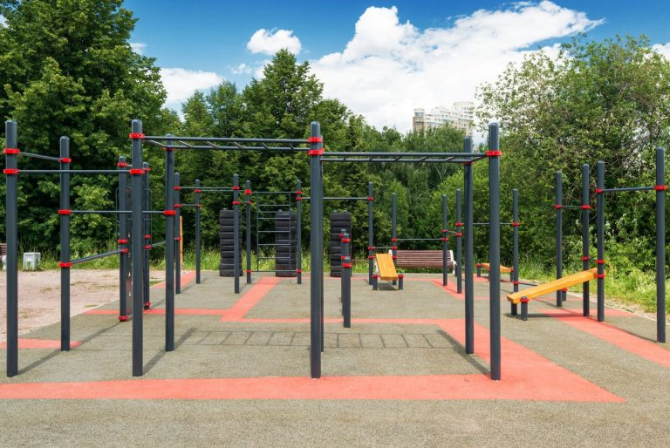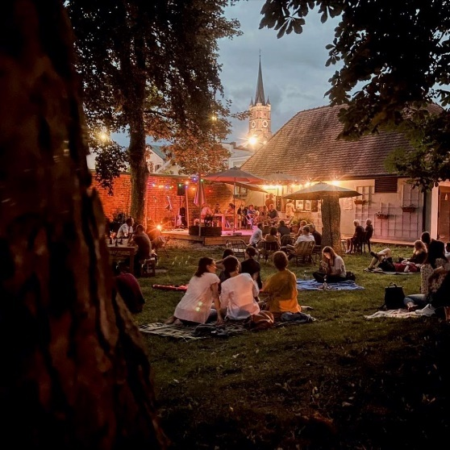

Figure 40: Image showing outdoor musical concert area in Pfarrkirchen and an outdoor calisthenics area. (Kenguru Pro, 2020)[23]

Adjacent to this is the fitness zone, this features both an indoor gym and an outdoor calisthenics area, this allows users to have exercise sessions in nature thereby combining the benefits of being in nature with the benefits of having an active lifestyle (Thompson Coon et al., 2011)[24] and promoting health and wellness among guest (Kellert et al., 2013)[25]. Convenient parking and bicycle facilities are strategically placed to encourage sustainable transportation options.

Guest accommodation areas are thoughtfully positioned to maximize comfort and sustainability, utilizing natural light and ventilation to reduce energy consumption as well as providing scenic views of the beach as well as surrounding nature. The beach view catering area provides an outdoor dining experience with scenic views of the beach, helping to enhance guests' connection to nature.

Additionally, the pool and water sport arena, along with jogging routes which route through carefully planned woody areas encourage physical activity and an active lifestyle in nature.

Additional amenities include a wellness and recreational area dedicated to relaxation and rejuvenation, a beach volleyball court to promote social interaction & physical activity, a calisthenics/outdoor gym to promote an active lifestyle and a kids play zone for family engagement. These elements collectively create a harmonious environment that emphasizes the well-being of both guests and the natural surroundings (Browning, Ryan, & Clancy, 2014).

## 2.7.0 Biophilic Design Principles

Biophilic design has been integrated at the core of this project, as it emphasizes the human connection with nature to enhance well-being and environmental stewardship. The design maximizes natural light and ventilation, reducing energy consumption while improving indoor air quality. Extensive green spaces and landscaping not only beautify the environment but also contribute to air purification.

1. Uba, D. (n.d.). Ilashe Beach, Lagos Nigeria. Flickr. https://www.flickr.com/photos/deveshuba/44888369594
2. Eludoyin, O. M., Adelekan, I. O., Webster, R., & Eludoyin, A. O. (2013). Air temperature, relative humidity, climate regionalization and thermal comfort of Nigeria. International Journal of Climatology, 34(6), 2000–2018. https://doi.org/10.1002/joc.3817
3. Lagos climate, weather by month, Average temperature (Nigeria) - Weather Spark. (n.d.). Weather Spark. https://weatherspark.com/y/48821/Average-Weather-in-Lagos-Nigeria-Year-Round
4. Lagos climate, weather by month, Average temperature (Nigeria) - Weather Spark. (n.d.). Weather Spark. https://weatherspark.com/y/48821/Average-Weather-in-Lagos-Nigeria-Year-Round
5. Lagos climate, weather by month, Average temperature (Nigeria) - Weather Spark. (n.d.). Weather Spark. https://weatherspark.com/y/48821/Average-Weather-in-Lagos-Nigeria-Year-Round
6. Lagos climate, weather by month, Average temperature (Nigeria) - Weather Spark. (n.d.). Weather Spark. https://weatherspark.com/y/48821/Average-Weather-in-Lagos-Nigeria-Year-Round
7. Lagos climate, weather by month, Average temperature (Nigeria) - Weather Spark. (n.d.). Weather Spark. https://weatherspark.com/y/48821/Average-Weather-in-Lagos-Nigeria-Year-Round
8. Lagos climate, weather by month, Average temperature (Nigeria) - Weather Spark. (n.d.). Weather Spark. https://weatherspark.com/y/48821/Average-Weather-in-Lagos-Nigeria-Year-Round
9. Lagos climate, weather by month, Average temperature (Nigeria) - Weather Spark. (n.d.). Weather Spark. https://weatherspark.com/y/48821/Average-Weather-in-Lagos-Nigeria-Year-Round
10.
11. Dr.A.J.Marsh. (2024). PD: Psychrometric Chart. Retrieved July 7, 2024, from https://drajmarsh.bitbucket.io/psychro-chart2d.html
12. Dr.A.J.Marsh. (2024). PD: Psychrometric Chart. Retrieved July 7, 2024, from https://drajmarsh.bitbucket.io/psychro-chart2d.html
13. Dr.A.J.Marsh. (2024). PD: Psychrometric Chart. Retrieved July 7, 2024, from https://drajmarsh.bitbucket.io/psychro-chart2d.html
14. Bridge.mp4. (2021, May 29). [Video]. Archtoolbox. https://www.archtoolbox.com/green-roof-systems/
15. 14 Patterns of biophilic design. (2014, September 12). Terrapinbrightgreen. https://www.terrapinbrightgreen.com/reports/14-patterns/#complexity-and-orde
16. Psychological benefits of leisure participation: A taxonomy of leisure activities based on their need-gratifying properties. (n.d.). https://psycnet.apa.org/doiLanding?doi=10.1037%2F0022-0167.42.2.123
17. Field, T. (2014). Massage therapy research review. Complementary Therapies in Clinical Practice, 20(4), 224–229. https://doi.org/10.1016/j.ctcp.2014.07.002
18. Mind–body interventions | Neurology. (n.d.). Neurology. https://www.neurology.org/doi/10.1212/01.wnl.0000314667.16386.5e
19. Frost, J. L. (1992). Play and playscapes. Cengage Learning.
20. Coon, J. T., Boddy, K., Stein, K., Whear, R., Barton, J., & Depledge, M. H. (2011). Does Participating in Physical Activity in Outdoor Natural Environments Have a Greater Effect on Physical and Mental Wellbeing than Physical Activity Indoors? A Systematic Review. Environmental Science & Technology, 45(5), 1761–1772. https://doi.org/10.1021/es102947t
21. Kaplan, R., & Kaplan, S. (1989). The experience of Nature: a psychological perspective. https://www.semanticscholar.org/paper/The-Experience-of-Nature%3A-A-Psychological-Kaplan-Kaplan/61f30c93c68064d8706ba7b6d3b57701bd1b9ffc
22. Miller, K. R., McClave, S. A., Jampolis, M. B., Hurt, R. T., Krueger, K., Landes, S., & Collier, B. (2016). The health benefits of exercise and physical activity. Current Nutrition Reports, 5(3), 204–212. https://doi.org/10.1007/s13668-016-0175-5
23. Kenguru Pro. (2020). Kenguru Pro 6. https://kengurupro.eu/download/Kenguru-Pro-Catalog-2020.pdf
24. Coon, J. T., Boddy, K., Stein, K., Whear, R., Barton, J., & Depledge, M. H. (2011). Does Participating in Physical Activity in Outdoor Natural Environments Have a Greater Effect on Physical and Mental Wellbeing than Physical Activity Indoors? A Systematic Review. Environmental Science & Technology, 45(5), 1761–1772. https://doi.org/10.1021/es102947t
25.